Page 122

Project 1

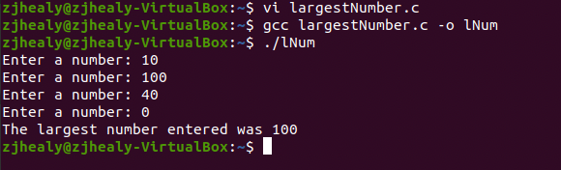

Page 159

Project 13

Project 14

1. how to define a specific output executable name.
   1. You use the command ‘gcc main.c -o ____’ and the blank would be what the executable name is.
2. how to enable all warning sets.
   1. Using the -Wall command, an example would be ‘gcc -Wall main.c -o main’
3. how to convert warnings into errors.
   1. Convert warnings to errors by using -Werror, an example would be ‘gcc -Wall -Werror main.c -o main’
4. how to print all the executed commands.
   1. You would use -v, a good example is ‘gcc -Wall -v main.c -o main’